Insert your name, centre number and candidate number into the header above.
Save this evidence document as evidence_ followed by your centre number_ candidate number. For example: evidence_ zz999_9999.doc
Screenshots or program listings must be copied into appropriate cells in the following tables.
Examiners must be able to read the contents including any screenshots without the use of a magnifying glass. Answers that are not readable or missing will not be awarded any marks.
Save this evidence document at regular intervals, for example, every 10 minutes.
Question 1
Part 1(a)
global HeadPointer, TailPointer, NumberItems, Queue
Queue = [-1] * 20
HeadPointer = -1
TailPointer = -1
NumberItems = 0

Part 1(b)
def Enqueue(item):
global HeadPointer, TailPointer, NumberItems, Queue
if NumberItems >= 20:
return False
if NumberItems == 0:
HeadPointer = 0
TailPointer += 1
Queue[TailPointer] = item
NumberItems += 1
if NumberItems < 20:
return True
else: return False

Part 1(c)
def main():
for i in range(1, 26):
if Enqueue(i):
print(f"{i} Successful.")
else: print(f"{i} Unsuccessful.")

if __name__ == "__main__":
main()

Part 1(d)
def Dequeue():
global HeadPointer, NumberItems, Queue
if NumberItems == 0:
return -1
res = Queue[HeadPointer]
NumberItems -= 1
HeadPointer += 1
return res

Part 1(e)(i)
def main():
for i in range(1, 26):
if Enqueue(i):
print(f"{i} Successful.")
else: print(f"{i} Unsuccessful.")
print(Dequeue())
print(Dequeue())

if __name__ == "__main__":
main()

Part 1(e)(ii)
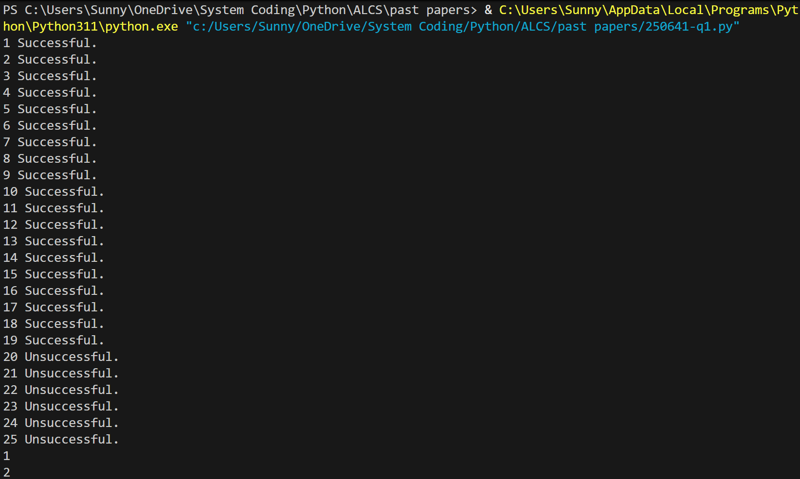

Question 2
Part 2(a)
def ReadData():
file = input("Enter file name: ")
try:
arr = []
with open(file, "r", encoding = "utf-8") as f:
for line in f:
arr.append(line.strip())
return arr
except IOError:
print("File does not exist.")

Part 2(b)
def SplitData(DataArray):
red = []
green = []
blue = []
orange = []
yellow = []
pink = []
for i in DataArray:
if "red" in i:
red.append(int(i[:i.index(",")]))
elif "green" in i:
green.append(int(i[:i.index(",")]))
elif "blue" in i:
blue.append(int(i[:i.index(",")]))
elif "orange" in i:
orange.append(int(i[:i.index(",")]))
elif "yellow" in i:
yellow.append(int(i[:i.index(",")]))
else:
pink.append(int(i[:i.index(",")]))

Part 2(c)
def StoreData(DataToStore, file):
try:
with open(file, "w") as f:
for i in DataToStore:
f.write(str(i) + "\n")
except:
print("Cannot write lines to file")

Part 2(d)
def SplitData(DataArray):
red = []
green = []
blue = []
orange = []
yellow = []
pink = []
for i in DataArray:
if "red" in i:
red.append(int(i[:i.index(",")]))
elif "green" in i:
green.append(int(i[:i.index(",")]))
elif "blue" in i:
blue.append(int(i[:i.index(",")]))
elif "orange" in i:
orange.append(int(i[:i.index(",")]))
elif "yellow" in i:
yellow.append(int(i[:i.index(",")]))
else:
pink.append(int(i[:i.index(",")]))
StoreData(red, "Red.txt")
StoreData(green, "Green.txt")
StoreData(blue, "Blue.txt")
StoreData(orange, "Orange.txt")
StoreData(yellow, "yellow.txt")
StoreData(pink, "pink.txt")

Part 2(e)(i)
def main():
arr = ReadData()
SplitData(arr)

if __name__ == "__main__":
main()

Part 2(e)(ii)
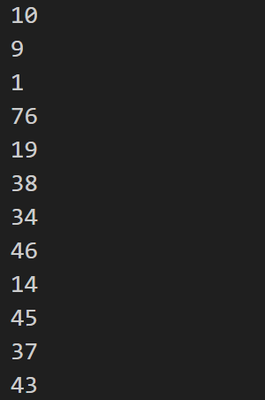

Question 3
Part 3(a)(i)
class Node:
def __init__(self, n):
self.__Nodedata = n #integer
self.__LeftNode = None #object Node
self.__RightNode = None #object Node

Part 3(a)(ii)
def GetLeft(self):
return self.__LeftNode
def GetRight(self):
return self.__RightNode
def GetData(self):
return self.__Nodedata

Part 3(a)(iii)
def SetLeft(self, a):
self.__LeftNode = a
def SetRight(self, a):
self.__RightNode = a

Part 3(b)
n1 = Node(10)
n2 = Node(20)
n3 = Node(5)
n4 = Node(15)
n5 = Node(7)

Part 3(c)(i)
class Tree:
def __init__(self, f):
self.__FirstNode = f #object Node
def Insert(self, data):
current = self.GetRootNode()
while True:
if data.GetData() >= current.GetData():
if current.GetRight() != None:
current = current.GetRight()
else:
current.SetRight(data)
break
else:
if current.GetLeft() != None:
current = current.GetLeft()
else:
current.SetLeft(data)
break
def OutputInOrder(self, n):
if n.GetLeft() != None:
self.OutputInOrder(n.GetLeft())
print(n.GetData())
if n.GetRight() != None:
self.OutputInOrder(n.GetRight())

Part 3(c)(ii)
def GetRootNode(self):
return self.__FirstNode

Part 3(c)(iii)
def Insert(self, data):
current = self.GetRootNode()
while True:
if data.GetData() >= current.GetData():
if current.GetRight() != None:
current = current.GetRight()
else:
current.SetRight(data)
break
else:
if current.GetLeft() != None:
current = current.GetLeft()
else:
current.SetLeft(data)
break

Part 3(d)
def OutputInOrder(self, n):
if n.GetLeft() != None:
self.OutputInOrder(n.GetLeft())
print(n.GetData())
if n.GetRight() != None:
self.OutputInOrder(n.GetRight())

Part 3(e)(i)
def main():
n1 = Node(10)
n2 = Node(20)
n3 = Node(5)
n4 = Node(15)
n5 = Node(7)
a = Tree(n1)
a.Insert(n2)
a.Insert(n3)
a.Insert(n4)
a.Insert(n5)
a.OutputInOrder(a.GetRootNode())
if __name__ == "__main__":
main()

Part 3(e)(ii)
